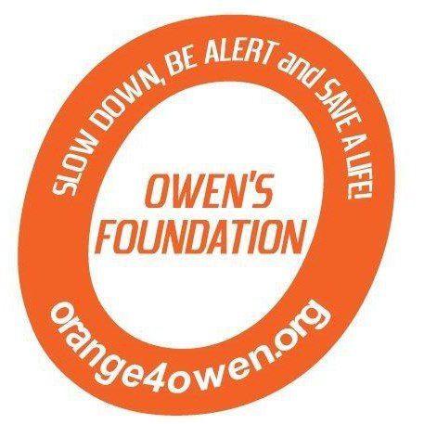 

3rd Annual **Orange 4 Owen** Memorial Golf Tournament

**Where**: Fairview Golf Course, Lebanon, PA

**When**: Saturday, June 7, 2014 at 1:30pm

The 3rd Annual Orange 4 Owen Memorial Golf Tournament will be held Saturday, June 7, 2014 at Fairview Golf Course in Lebanon, PA. We hope you will be part of our day.

We ask you to consider being a sponsor of this year’s tournament. Your sponsorship will help us continue our mission to educate others about the dangers of distracted driving and remind everyone to Slow Down, Be Alert and Save a Life!

The day will feature lunch and dinner for the golfers as well as food, fun, raffles and much more for those not hitting the links. Dinner will be available for those that choose not to golf and we will also feature a silent auction during the dinner hour. If you are unable to be a sponsor for one of the items below, please consider donating an item such as sports memorabilia, tickets, gift certificates or any item that is unique to your company – and if it is **Orange**, even better!

**Sponsorship Opportunities – Due by May 30, 2014**

|  |  |  |
| --- | --- | --- |
| **Orange - $5,000**   * Sign recognition at entrance, registration table, dinner and golf course * 8 golfers including dinner * Sponsor logo on website and Facebook page * Full page ad in program   **Platinum - $2,500**   * Sign recognition at registration table, dinner and golf course * 4 golfers including dinner * Sponsor logo on website and Facebook page * Full page ad in program   **Diamond - $1,000**   * Signage on course * 2 golf entries and dinner * Sponsor logo on website and Facebook page * Half page ad in program | **Hole Sponsor**  **Gold - $500**   * Exclusive signage at one hole * Signage displayed at dinner * Sponsor logo on website and Facebook page * Logo displayed in program   **Silver - $100**   * Signage with up to four other sponsors at one specific hole * Signage displayed at dinner * Sponsor logo on website and Facebook page * Name listed in program | **Cart Path Signage**  **Bronze - $50**   * Signage along cart path recognizing your organization or a message to a loved one * Name listed in program |

Please contact us at [orange4owen@comcast.net](mailto:orange4owen@comcast.net) if you have any questions and keep checking [www.orange4owen.org](http://www.orange4owen.org) for updated golf tournament information. Please make checks payable to “**Orange 4 Owen**”. Thank you in advance!

Sincerely,

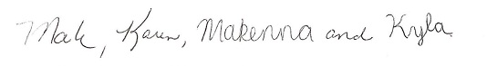

Mark, Karen, Makenna and Kyla Brezitski