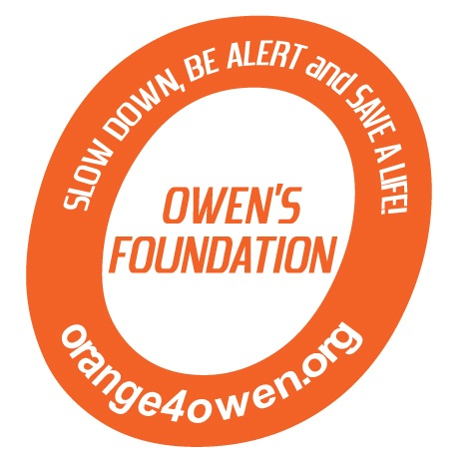
Golf/Dinner Registration Form

Name: ______________________________________________
Address: ____________________________________________
City ______________________________ State __________ Zip ___________
Telephone (______) _____________________
Email ________________________________________
Individual Golfer $88 ___ × $88 = $_____ (We will place you with a foursome if needed)
Foursome $352 $352 = $_____
Dinner only $25 ea (13 yrs & up) ___ × $25 = $_____
$15 ea (5 -12 yrs) ___ × $15 = $_____
FREE (4 yrs & under)
TOTAL = $ ______ Make checks payable to “Orange 4 Owen”

Buffet Dinner to begin at approximately 6:00pm – limited seating for non-golfers
Raffle and Silent Auction will take place during dinner.

Foursome:
1._____________________________________Cell: ________________
2._____________________________________
3._____________________________________
4._____________________________________

Contact us at: orange4owen@comcast.net
Golfer registration includes greens fee, cart, boxed lunch, and buffet dinner. Prizes for longest drive, closet to the pin, low score, etc.

Please make check(s) payable to Orange 4 Owen
Mail to: Owen’s Foundation
P.O. Box 6084
Harrisburg, PA 17112

Thank you for your support!
I am unable to attend, but I am enclosing my donation of $__________.

Owen’s Foundation is a charitable fund of The Foundation for Enhancing Communities. Orange 4 Owen is a project of the Foundation for Enhancing Communities, fiscal sponsor. The official registration and financial information of The Foundation for Enhancing Communities may be obtained from the Pennsylvania Department of State or by calling toll-free, within Pennsylvania, 1-800-732-0999. Registration does not imply endorsement.

3rd Annual Orange 4 Owen Memorial Golf Tournament
Fairview Golf Course
Lebanon, PA
June 7, 2014
1:30 p.m. shotgun start
4 person scramble

