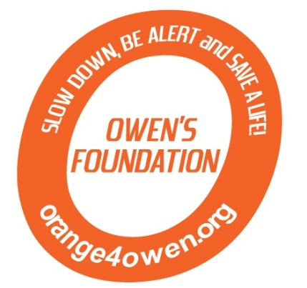

**Please make check(s) payable to** **Orange 4 Owen**

**and mail this form along with payment to:**

Owen’s Foundation

P.O. Box 6084

Harrisburg, PA 17112

2nd Annual Orange 4 Owen Memorial Golf Tournament

Fairview Golf Course

Lebanon, PA

June 8, 2013

1:30 p.m. shotgun start

4 person scramble

**Thank you for your support!**

**Sponsorship Form**

Contact Information:

Name: ______________________________________________

Address: ____________________________________________

City ______________________________ State ________ Zip ___________

Telephone (______) _____________________

Email ________________________________________

Sponsorship Opportunities: Quantity

Orange Sponsor - $2,500.00 _________

Platinum Sponsor - $1,000.00 _________

Gold (Exclusive Hole) Sponsor - $500.00 _________

Silver (Hole) Sponsor - $100.00 _________

Bronze (Cart Path) Sponsor - $50.00 _________

Total = $_________

Logo: (circle/underline one) **YES NO**

Slogan for sign(s) - _____________________________________________________________

____________________________________________________________________________

If logo is to be included on sign(s), please send it to [**syingling@dasprint.com**](mailto:sy@dasprint.com) and **orange4owen@comcast.net** in a high resolution PDF file or a Vector file along with this form.

Contact us at: **orange4owen@comcast.net**

*The official registration and financial information of The Foundation for Enhancing Communities may be obtained from the Pennsylvania Department of State or by calling toll-free, within Pennsylvania, 1-800-732-0999. Registration does not imply endorsement. Orange 4 Owen is a project of the Foundation for Enhancing Communities, fiscal sponsor.*