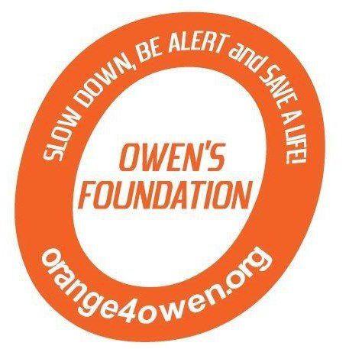 

2nd Annual **Orange 4 Owen** Memorial Golf Tournament

Where: Fairview Golf Course, Lebanon, PA

When: June 8, 2013 at 1:30pm

The 2nd Annual Orange 4 Owen Memorial Golf Tournament will be held June 8, 2013 at Fairview Golf Course in Lebanon, PA. We hope you will be part of our celebration.

We ask you to consider being a sponsor of this year’s tournament. Your sponsorship will help us continue our mission to educate everyone about the dangers of distracted driving and remind everyone to Slow Down, Be Alert and Save a Life.

The day will feature lunch and dinner for the golfers as well as food, fun, games, raffles, nail painting and much more for those not hitting the links. Dinner will also be available for those that chose not to golf. We will also feature a silent auction during dinner. If you are unable to be a sponsor for one of the items below, please consider donating an item such as sports memorabilia, tickets, gift certificates or any item that is unique to your company – and if it is **Orange,** even better!

**Sponsorship Opportunities**

|  |  |  |
| --- | --- | --- |
| **Orange - $2,500**   * Sign recognition at registration table, dinner and golf course * 4 golf entries * Sponsor logo on website and Facebook page * Full page ad in program   **Platinum - $1,000**   * Signage on course * 2 golf entries * Sponsor logo on website and Facebook page * Half page ad in program | Hole Sponsor  **Gold - $500**   * Exclusive signage at that hole * Signage displayed at dinner * Sponsor logo on website and Facebook page * Logo displayed in program   **Silver - $100**   * Signage with up to four other sponsors at one specific hole * Signage displayed at dinner * Sponsor logo on website and Facebook page * Name listed in program | Cart Path Signage  **Bronze - $50**   * Signage along cart path recognizing your organization or a message to a loved one * Name listed in program |

Please contact us at [orange4owen@comcast.net](mailto:orange4owen@comcast.net) if you have any questions and keep checking [www.orange4owen.org](http://www.orange4owen.org) for updated golf tournament information. Thank you in advance!

Sincerely,

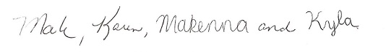

Mark, Karen, Makenna and Kyla Brezitski