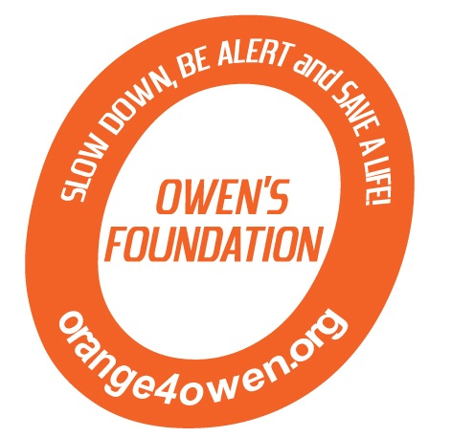
Golf/Dinner Registration Form

Name: ______________________________________________
Address: ____________________________________________
City ______________________________ State __________ Zip ___________
Telephone (______) _____________________
Email ________________________________________
Individual Golfer $88 (Dinner included) ___ × $88 = $_____ (We will place you with a foursome if needed)
Foursome $352 $352 = $_____
Dinner only $25 ea (13 yrs & up) ___ × $25 = $_____
$12 ea (5 -12 yrs) ___ × $12 = $_____
FREE (4 yrs & under)
TOTAL = $ ______

Buffet Dinner to begin at approximately 6:30pm – limited seating for non-golfers
Raffle and Silent Auction will take place during dinner.

Foursome:
1._____________________________________Cell: ________________
2._____________________________________
3._____________________________________
4._____________________________________

Contact us at: orange4owen@comcast.net
Golfer registration includes greens fee, cart, boxed lunch, and buffet dinner. Prizes for longest drive, closet to the pin, low score, etc.

Please make check(s) payable to Orange 4 Owen
Mail to: Owen’s Foundation
P.O. Box 6084
Harrisburg, PA 17112

Thank you for your support!
I am unable to attend, but I am enclosing my donation of $__________.

The official registration and financial information of The Foundation for Enhancing Communities may be obtained from the Pennsylvania Department of State or by calling toll-free, within Pennsylvania, 1-800-732-0999. Registration does not imply endorsement. Orange 4 Owen is a project of the Foundation for Enhancing Communities, fiscal sponsor.

2nd Annual Orange 4 Owen Memorial Golf Tournament
Fairview Golf Course
Lebanon, PA
June 8, 2013
1:30 p.m. shotgun start
4 person scramble

